实验报告（第四次上机）

电自2003 赵洪

#include<iostream>

#include<cmath>

#include<string>

using namespace std;

class tstudent {

private:

static float m_classmoney;

string name;

public:

static void showmoney();

void initstudent(string name1);

void expendmoney(float money);

};

float tstudent::m_classmoney = 1000;

void tstudent::initstudent(string name1)

{

name = name1;

}

void tstudent::expendmoney(float money)

{

m_classmoney = m_classmoney - money;

}

void tstudent::showmoney()

{

cout << "There is " << m_classmoney << "yuan left" << endl;

}

int main()

{

int i;

float b[3];

string a[3];

tstudent s1, s2, s3;

for (i = 0; i < 3; i++)

{

cout << "Please input student's name: " << endl;

cin >> a[i];

cout << "Please input how much money did this student spend: " << endl;

cin >> b[i];

}

s1.initstudent(a[0]);

s1.expendmoney(b[0]);

s2.initstudent(a[1]);

s2.expendmoney(b[1]);

s3.initstudent(a[2]);

s3.expendmoney(b[2]);

s1.showmoney();

return 0;

}

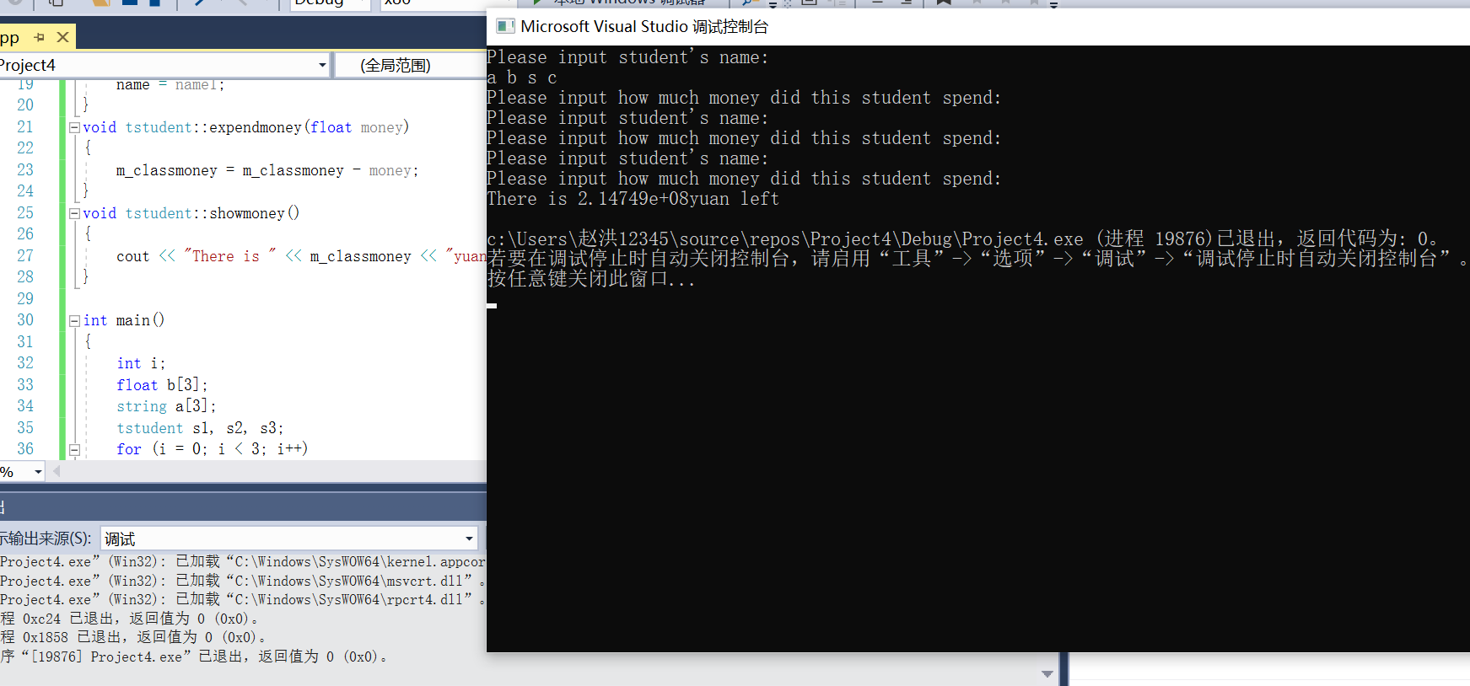

通过本次实验，我初步掌握了静态成员的概念和使用。静态成员是由关键字static修饰说明的成员。静态数据成员实现对象之间的数据共享，静态成员函数用以处理静态数据成员，必要的时候静态成员函数可以通过对象名(或对象指针，对象引用)访问该对象的非静态成员。